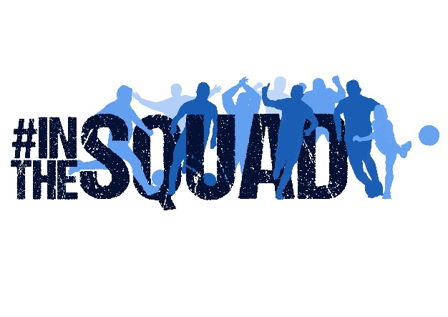

Questionnaire 2017/18

Name
Where do you stand/sit?
What can you remember about your first-ever Pools game?
How did you first start watching Pools and who brought you to your first game?
Which has been your favourite ever Pools game and why?
Who is your all-time favourite Pools player and why?
Who is your all-time favourite Pools Manager and why?
Can you describe the best goal you’ve seen scored by a Pools player?
What has been your best moment as a Pools fan so far?
What are your hopes for the 2017/18 season?
What three words would you say sum up being a Pools fan?

Once you’ve completed this questionnaire, simply send it back to us (with a photo of yourself if possible) to media@hartlepoolunited.co.uk

Thank you for your support.

